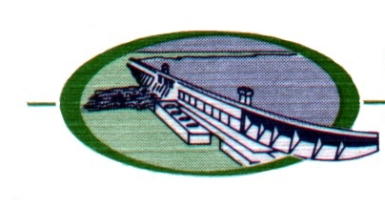
DEMOLITION PERMIT APPLICATION

Permit # ________
City of Lake Ozark
P.O. Box 370
Lake Ozark, MO 65049
LAKE OZARK
(573) 365-5378

SITE/ PROPERTY INFORMATION
App. Date: | Street Address:
Subdivision: |  | Zoning: | Lot Number:

OWNER(S) INFORMATION
Name: |  | Address:
City: | State: | Zip: | Phone #: ( )

CONTRACTOR INFORMATION
Company Name: |  | Contact Name:
Mailing Address: |  |  | License #:
City: | State: | Zip: | Phone #: ( )
Start Date: |  | Est. Completion Date:

REQUIREMENTS, SPECIAL INSTRUCTIONS AND/OR NOTES
- If a DNR permit is required, a copy of the DNR permit shall be submitted with the City application.
- Existing City utilities shall be disconnected with the supervision and approval of the Public Works Director. The applicant or contractor shall be responsible for contacting the City at (573) 365-5378 to coordinate any inspections.
- Demolition permits require a final inspection by the Building Department when the project is complete

I certify that I am familiar with the State and City requirements for the demolition of existing buildings. I further certify that I will schedule all required inspections and maintain a safe and secure job site for the duration of the project.

Signature of Applicant: ________________________________________________ Date: ____________________________

Do not write below this line – OFFICIAL USE ONLY

FEE PAID: $ __________ APPROVED: YES NO

__________________________________________________________________________ ___________________________
Approval Signature / Title Issue Date

__________________________________________________________________________ ___________________________
Project Completion Signature Approved Completion Date

THIS PERMIT MUST BE POSTED ON SITE AND VISIBLE FROM THE STREET

