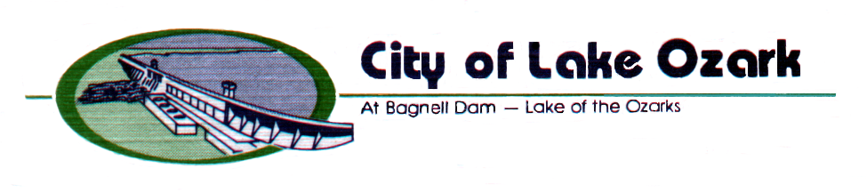
3162 Bagnell Dam Blvd.
Lake Ozark, MO 65049
573/365-5378 FAX 573/365-4515
www.cityoflakeozark.net

NOTICE OF SPECIAL MEETING

Lake Ozark Board of Aldermen
Special Session
June 3, 2022 – 1:00 P.M.
Lake Ozark City Hall

*** Note: Please turn your cell phone off or on silent. Sign the attendance sheet located at the podium if you desire to address the Board.

CALL TO ORDER

ROLL CALL

APPROVAL OF AGENDA

OLD BUSINESS None at this time

NEW BUSINESS

- Bill No. 2022-14; Approving a Second Amended Plat for Arrowhead Estates, submitted by Larry Shields.

ADJOURNMENT

