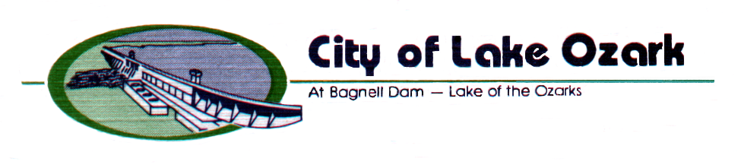
3162 Bagnell Dam Blvd.
Lake Ozark, MO 65049
573/365-5378 FAX 573/365-4515
www.cityoflakeozark.net

NOTICE OF MEETING

Lake Ozark Board of Aldermen
Regular Session
August 9, 2022 – 6:00 P.M.
Lake Ozark City Hall

*** Note: Please turn your cell phone off or on silent. Sign the attendance sheet located at the podium if you desire to address the Board.

CALL TO ORDER

PLEDGE OF ALLEGIANCE

ROLL CALL

MAYOR’S COMMUNICATIONS

CITIZEN COMMUNICATIONS

- This time is set aside on the Agenda for citizens and visitors to address the Mayor and Board of Aldermen on any topic that is not a Public Hearing. The Board of Aldermen cannot take action on any item not listed on the Agenda, but the Mayor and Board do welcome and value input and feedback from the public. Speakers will be restricted to three minutes for non-agenda items; five minutes for agenda items unless otherwise permitted. Minutes may not be donated or transferred from one -speaker to another.
APPROVAL OF CONSENT AGENDA

- Agenda 1-3
- Minutes; July 26, 2022 Regular Meeting 5-8
- Reports:
- Assistant City Administrator / Director of Community Development 9
- City Clerk
- Caterer’s License; The Dinghy (Sunny’s Marina), 11
- Hidden Acres, August 20, 2022
- Police Chief 13-15
- Treasurer 17
- July Financials side pocket

OLD BUSINESS

- Bill No. 2022-18; Amending Code Section 130.280 by approval of 19-20
qualified voters reallocating the existing one-half of one percent
sales tax (second reading)

- Bill No. 2022-19; Amending Code Section 130.240 to allow capital 21-23
improvement sales tax (approved on November 3, 1987) to be used for
sewer and water improvements and extensions, road infrastructure
and payment of bonded indebetedness related to capital improvements.
(first reading)

- Bill No. 2022-20; Approving an Agreement between the City and 25-31
certain establishments licensed to sell liquor by the drink (Shootout
Meet and Greet; August 24, 2022) (second reading)

NEW BUSINESS

- Bill No. 2022-21; Approving a final plat for LCMC Enterprises 33-37
No. 3. Subdivision (first reading)

- Resolution No. 2022R-20; accepting proposal from Rogers Heating 39-41
and Air Conditioning (City Hall HVAC)

- Approval of July Bills side pocket

- Resolution No. 2022R-21; Approving and accepting a proposal 43-45
from Vance Brothers, Inc. for slurry seal project

- Resolution No. 2022R-22; Appreciation, approving and accepting a 47-48
donation of $25,000 from Indian Motorcycle

- Approval of trash and litter letter 49-51

- Special Event; Bikefest, Bagnell Dam Blvd. September 14-18, 2022 53-60

- Open Container Application; Bikefest, September 15-19, 2022 61-63

- Ordinance No. 2022-22; Approving an Agreement between the City 65-70
and certain establishments licensed to sell liquor by the drink
(Bikefest; September 15-19, 2022) (first reading)

- 2022 Budget Amendment update 71-73

- Update on ARPA funds / cameras

COMMUNICATIONS FROM MEMBERS OF THE BOARD OF ALDERMEN

STAFF COMMUNICATIONS

ADJOURNMENT

If any member of the public requires a specific accommodation as address by the American with Disabilities Act, please contact the City Clerk’s office 48 hours in advance of the meeting at the telephone number above.

